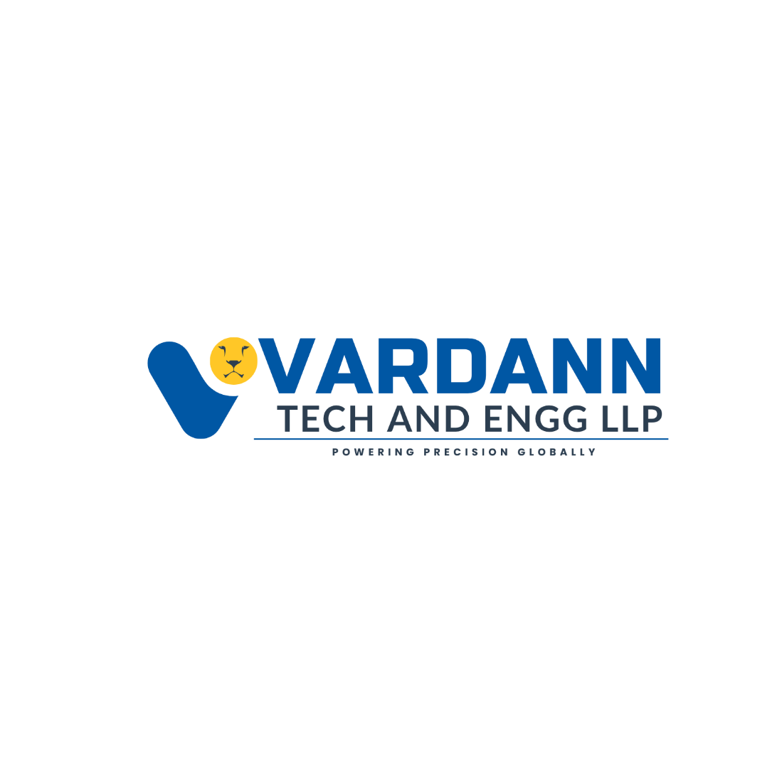



COMPANY  PROFILE | www.vardanntech.com
Formerly known as ADVANCED NDT SERVICES LLP
We have rebranded as VARDANN TECH and ENGG LLP to reflect our broader vision and global commitment to engineering excellence.
About Us | 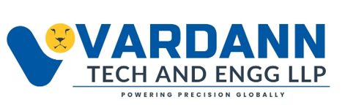
VARDANN TECH AND ENGG LLP is an independently owned, globally recognized manufacturer and engineering solutions provider specializing in Non-Destructive Testing (NDT), Inspection Services, Metallography, Precision Manufacturing, and Engineering Solutions.

Established in 2019, we are committed to delivering engineering excellence through innovative manufacturing, precision inspection, and ethical engineering practices. Our products and services are trusted by clients across India, the Middle East, Africa, and the Asia-Pacific region.

VISION
To establish VARDANN TECH as a global symbol of precision, innovation, integrity, and trust in NDT and metallurgical engineering.

MISSION
To innovate with purpose, engineer with precision, and deliver with uncompromising integrity while creating reliable solutions that exceed customer expectations.

INSPECTION SERVICES
ADVANCED NDT | CONVENTIONAL NDT
1. Eddy Current Testing-(ECT)  2. Remote Field Testing-(RFT)  3. Internal Rotary Inspection System-(IRIS)  4. Phased Array Ultrasonic Testing-(PAUT)  5. Time of Flight Diffraction-(TOFD)  6. Remote Visual Inspection/Boroscopy  7. Long Range Ultrasonic Testing-(LRUT) | 1. Ultrasonic Flaw Detection  2. Ultrasonic Thickness Gauging / High Temperature Thickness gauge  3. Magnetic Particle Testing  4. Dye Penetrant Testing  5. Hardness Testing  6. Radiography Testing  7. Coating Thickness Measurement

SPECIALIZED & THIRD-PARTY INSPECTION
- QA/QC Supervision and Welding Inspection
- Vendor Surveillance and Commodity Inspection
- Positive Material Identification (PMI)
- Optical Emission Spectroscopy (OES)
- In-Situ Metallography and Microstructure Analysis
- Post Weld Heat Treatment

MANUFACTURING & PRODUCTS
CALIBRATION BLOCK TUBES & PROBES WELDED SPECIMENS

- Manufactured per ASME standards for ECT, RFT, NFT, IRIS applications with 30+ material specimens.
- Custom tubes and mock-up exchangers delivered within 3–6 days, designed for multiple methods including ECA, MFL, NFA, NFT.
- Calibration Blocks
- IIW Type 1 & 2, V1, V2, and ASME Sec V Blocks
- Welded Specimens (PAUT/TOFD/UT)
Step Wedges & Custom Pipe Blocks, CNC / EDM machined with NABL/NPL traceability

  INDUSTRIES WE SERVE | Zero compromise towards safety.

Our Product | 

CALIBRATION TUBES & PROBES FOR TUBE INSPECTION
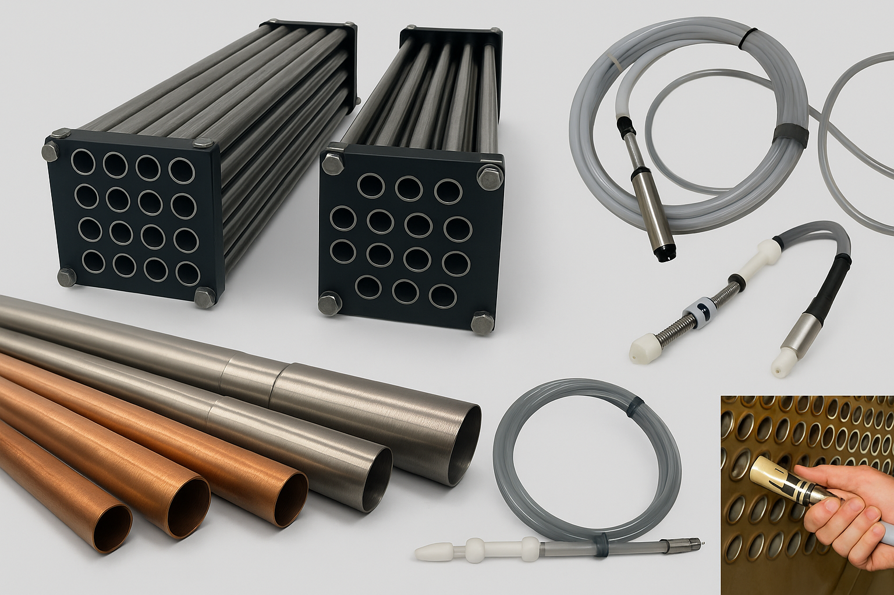
We are a leading manufacturer of various types of calibration tubes and ECT probes for tubular inspection as per ASME standards or customer requirements. Our core manufacturing covers ECT, RFT, NFT, IRIS, and custom standards. Over 30 materials are available in assorted alloys, diameters, and wall thicknesses. Calibration tubes are precisely machined using milling, lathe, or EDM, and all measuring devices are certified. Custom orders typically ship within 3–6 days. We also design mock-up exchangers or tube bundles for training and testing in ECT, RFT, IRIS, ECA, MFL, and NFT methods.

ECT & RFET PROBES
Our range includes straight and flexible ECT-RFT-NFT probes with TUD cables designed for precise tubular inspection applications. Probes are compatible with leading NDT systems and ensure consistent, high-quality performance for field and laboratory testing.
Watch our calibration tubes in action on Instagram/YouTube: @vardanntech

“Quality means doing it right when no one is looking.”

ULTRASONIC TRANSDUCERS, CABLES & ACCESSORIES
Our ultrasonic transducers come in multiple frequencies, diameters, and connector styles for accurate flaw detection and thickness gauging. Matching cables and accessories ensure stable, noise-free performance with all major NDT instruments.
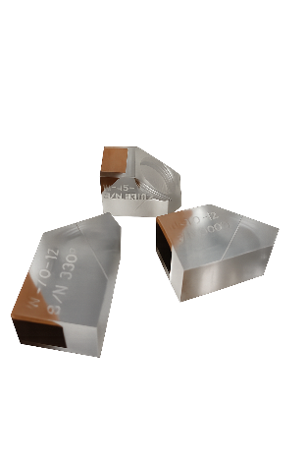
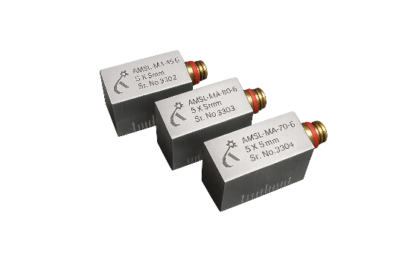
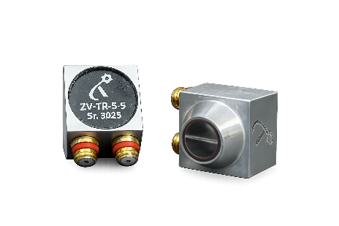
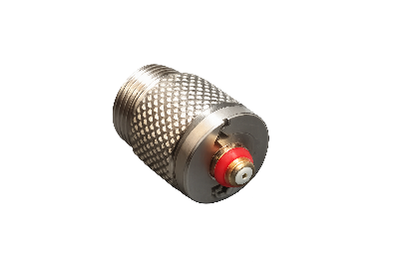
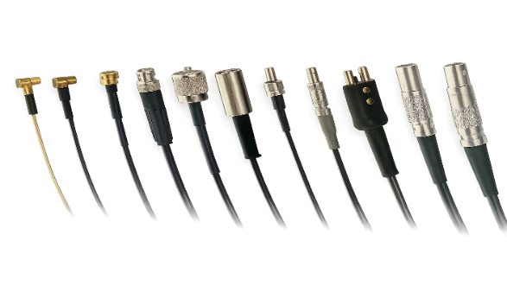
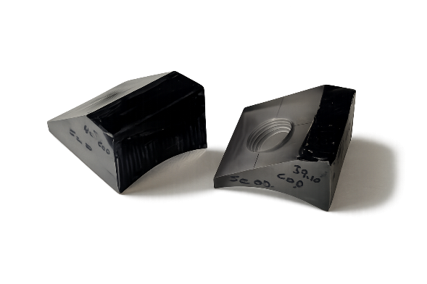
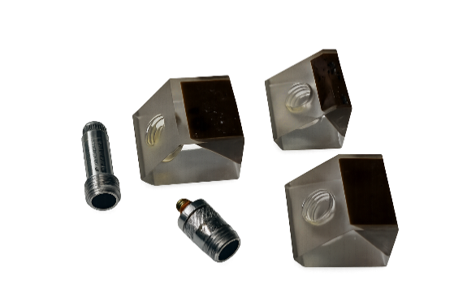
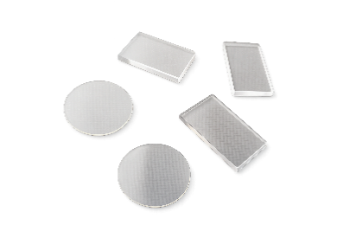
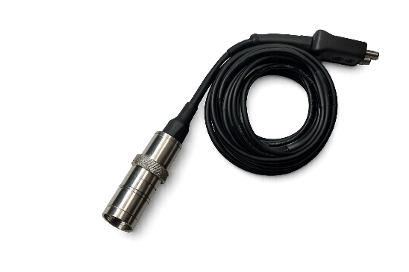
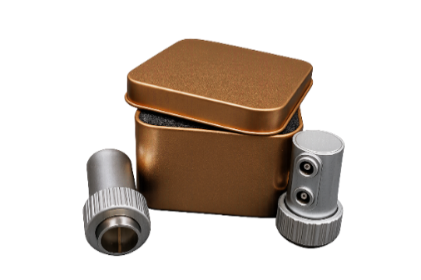
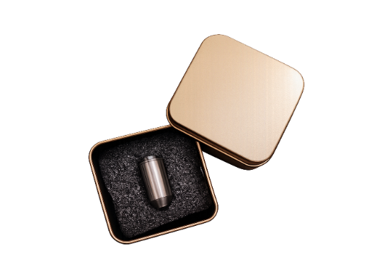
We are Manufacturer of Customized Probes, AOD/COD Wedges, Membranes & Probe Shoes

MINATURE ANGLE BEAM PROBES, CUSTOMISED PROBE AND WEDGES TR PROBES NORMAL PROBES CABLES MEMBRANES AOD AND COD WEDGES
Our Product | 

ULTRASONIC TEST BLOCK

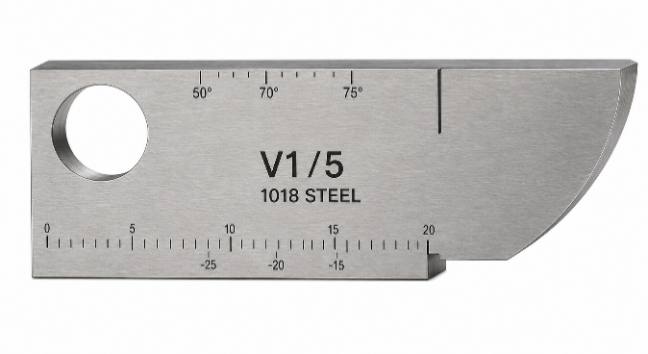 | 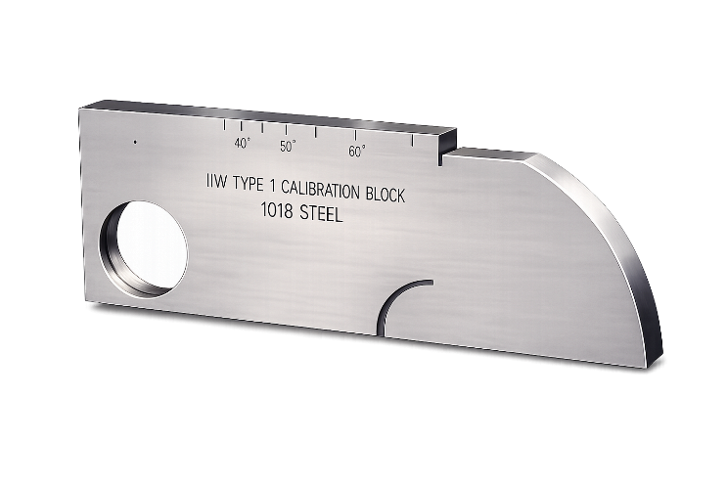
Block Type: V1/5 (A2) Test Block Standard: ISO 2400 BS 2704  Material Option: CS, MS, SS, AL | Block Type: IIW-Type 1 Block Test Block Standard: ISO2400-1972E ASTM E164  Material Option: CS, MS, SS, AL

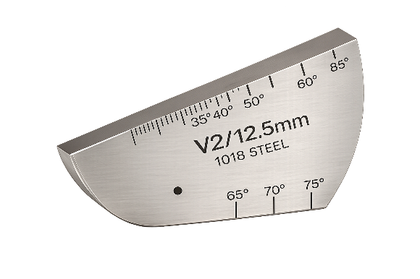 | 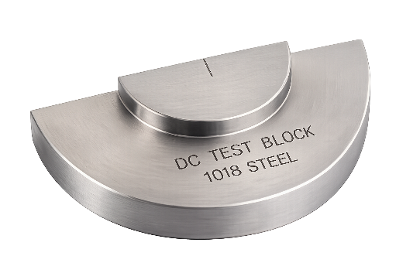 | 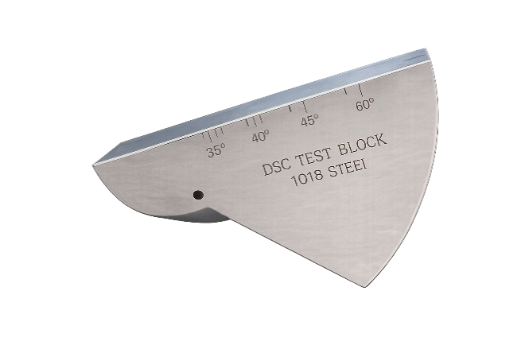
Block Type: V2 Test Block Standard: BS 2704 ISO 7963 Material Option: CS, MS, SS, AL | Block Type: DC Block Standard: ASTM E164 BRR/AWS X-1 Material Option: CS, MS, SS, AL | Block Type: DSC Test Block Standard: ASTM E164  AWS 6.16.1B Material Option: CS, MS, SS, AL

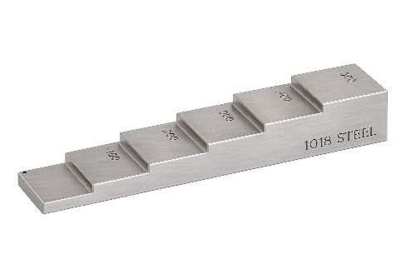 | 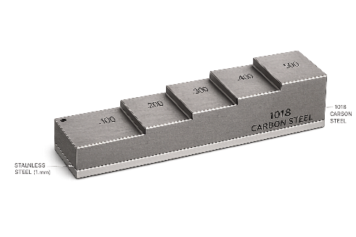 | 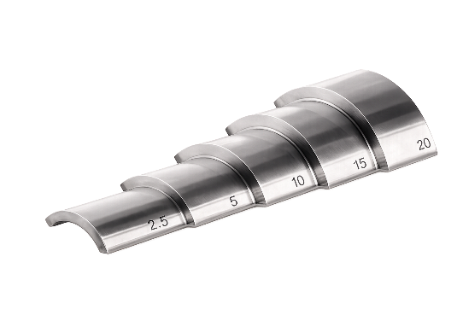
Block Type: V2 Test Block Standard: BS 2704 ISO 7963 Material Option: CS, MS, SS, AL | Block Type: DC Block Standard: ASTM E164 BRR/AWS X-1 Material Option: CS, MS, SS, AL | Block Type: DSC Test Block Standard: ASTM E164  AWS 6.16.1B Material Option: CS, MS, SS, AL

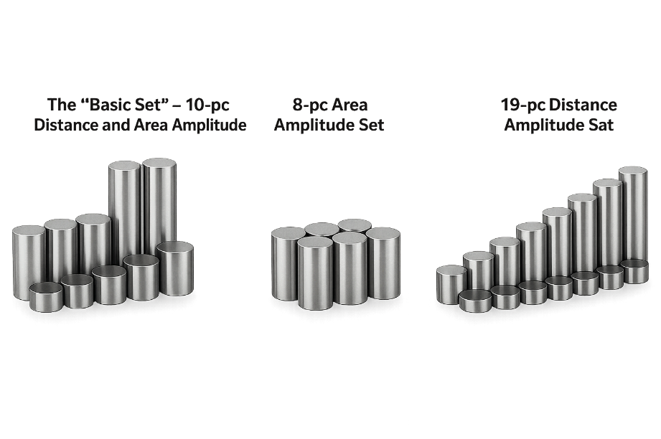 | 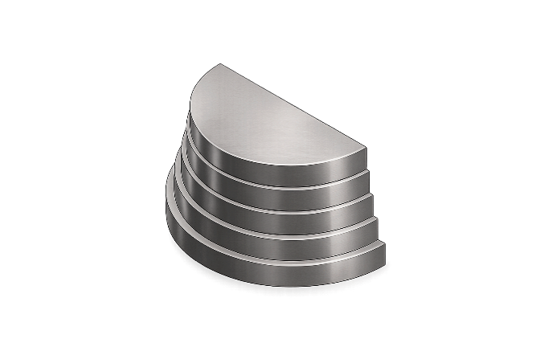
ASTM E127 Flat-bottom Hole (FBH) Block Sets are made up of (most often) cylindrical metal blocks that have a single FBH drilled into one end. They're used to evaluate the performance of ultrasonic equipment for longitudinal (straight beam) inspection, and can be used for direct contact inspection or immersion.

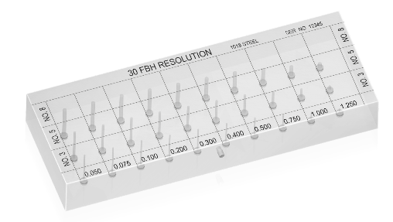 | 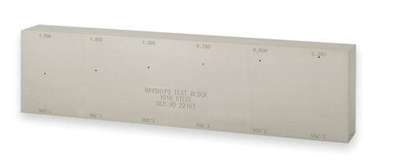
30 FBH BLOCK | NAVSHIPS TEST BLOCK

Custom calibration blocks are available, like chrome-nickel alloy, aluminum, cast iron, refractory alloy, etc.
Specification: Metrics and Inches

Our Product | 

EXPERTISE IN ULTRASONIC TESTING (UT) OF SEAMLESS PIPES

VARDANN TECH and ENGG LLP, we specialize in Manual Ultrasonic Testing (UT) using custom-engineered wedges and probes designed as per ASTM E213. Our expertise covers inspection of highly challenging materials such as Inconel, Duplex Stainless Steel, Stainless Steel, and Tantalum, ensuring precise evaluation of seamless tubes and pipes even under demanding conditions.

We have successfully developed UT techniques capable of detecting both Transverse and Longitudinal defects, achieving high sensitivity on extremely thin sections.
✔ Lowest wall thickness achieved: 1.65 mm, maintaining clear defect resolution and stable signal performance.

Our inspection methodologies have supported projects in the nuclear, aerospace and research sectors, including organizations such as BARC, NPCIL and ISRO through customer applications

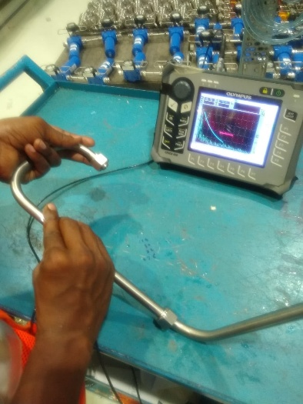 | 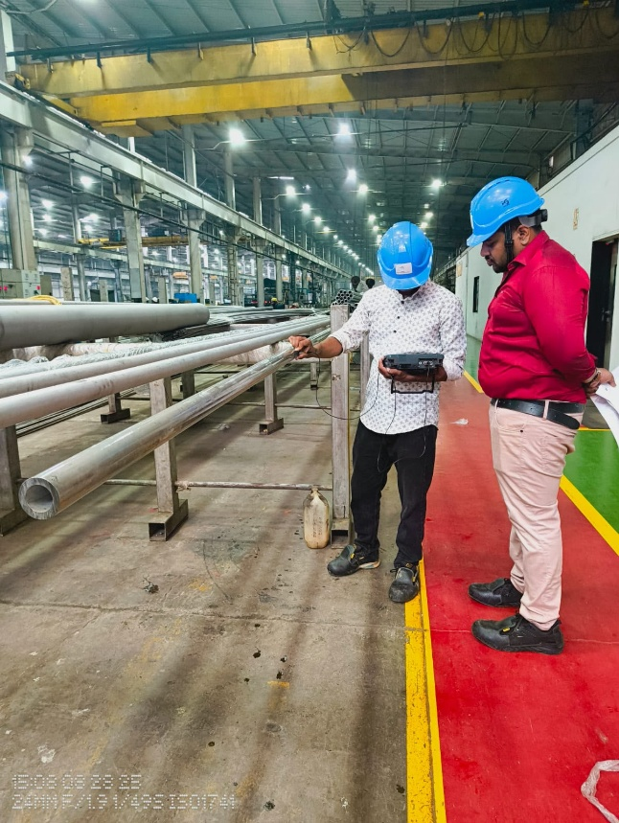

MAGNETIC PARTICLE TESTING (MPI) KITS

Our MPI yokes are built for speed, reliability, and rugged industrial conditions.
They are available in AC/DC outputs for quick crack detection in ferromagnetic materials.

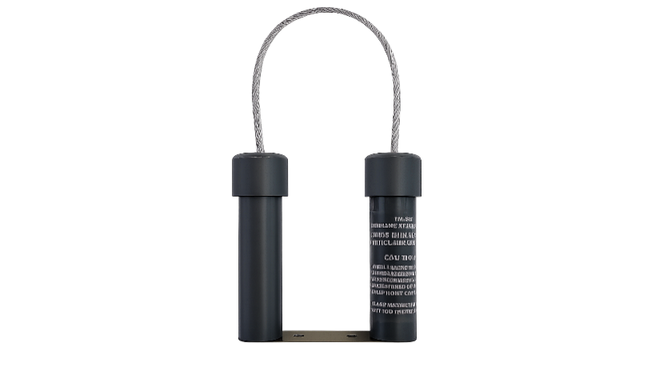
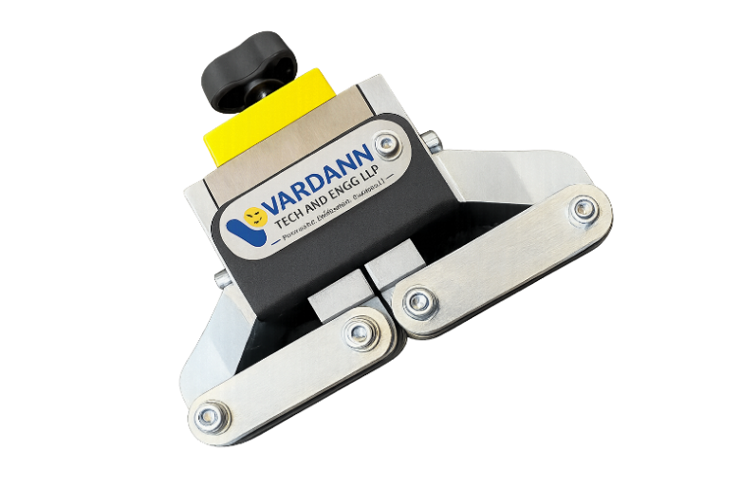
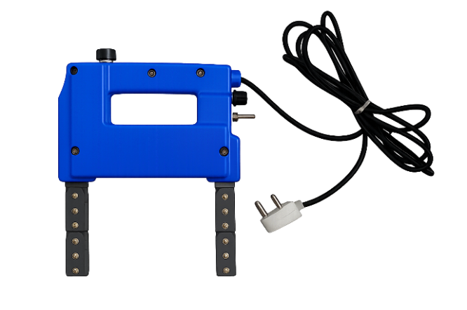
AC/DC Yoke |  | Permanent Magnet Yoke with ON/OFF Switch |  |  | Permanent Magnet Yoke
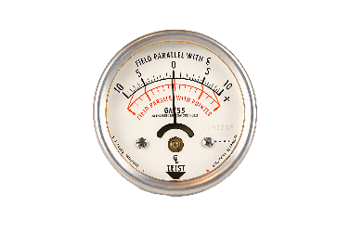
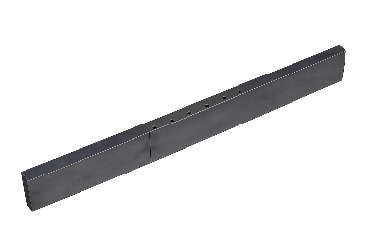
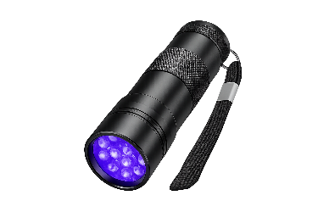
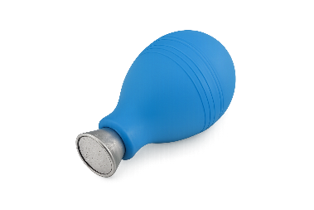
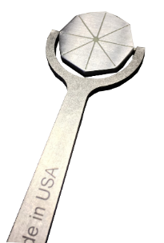
Field Indicator | Blower |  | UV Torch | ASTM Test Block |  | Gauss Meter

Our Product | 
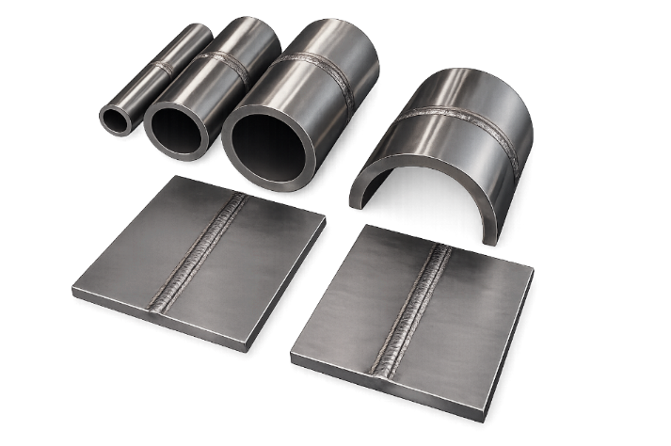
WELDED FLAWED SPECIMENS
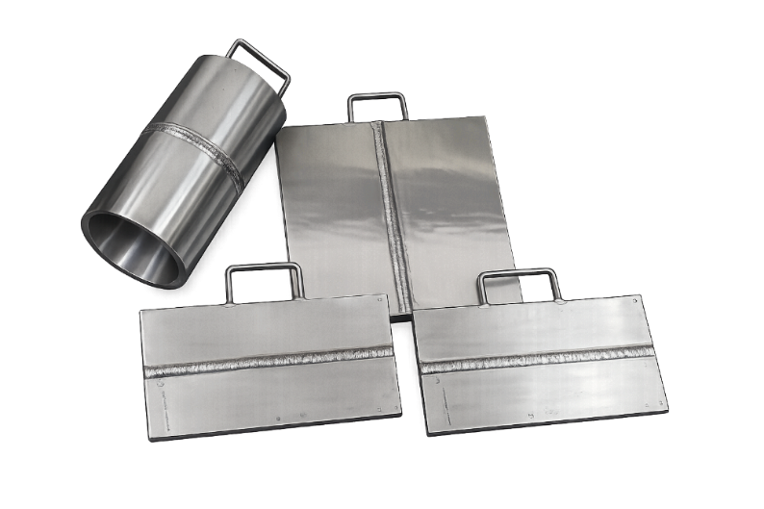

VARDANN TECH and ENGG LLP manufactures and supplies high-quality Welded Flawed Specimens for NDT training, personnel qualification, procedure validation, equipment performance evaluation, demonstration, and inspection capability assessment.

Our specimens are manufactured using a wide range of materials, including Carbon Steel, Stainless Steel, Alloy Steel, Duplex Stainless Steel, Nickel Alloys, Aluminium, Titanium, Copper Alloys, and other materials as specified by the customer.

We offer complete customization to meet customer requirements, including material grade, dimensions, plate or pipe configuration, weld joint design, flaw type, flaw size, flaw location, acceptance standards, and specific NDT applications. Every specimen is manufactured with precision to ensure reliable, repeatable, and realistic inspection performance.

MANUFACTURING SERVICES:
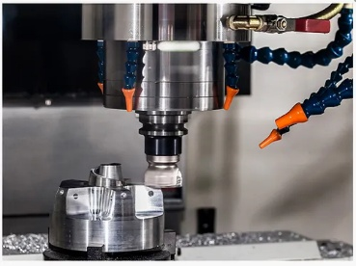
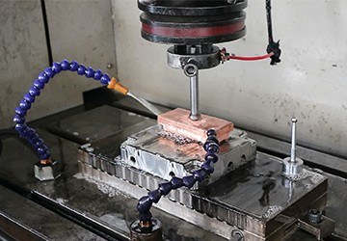
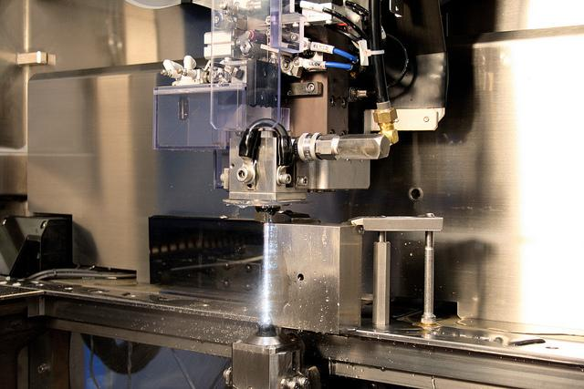
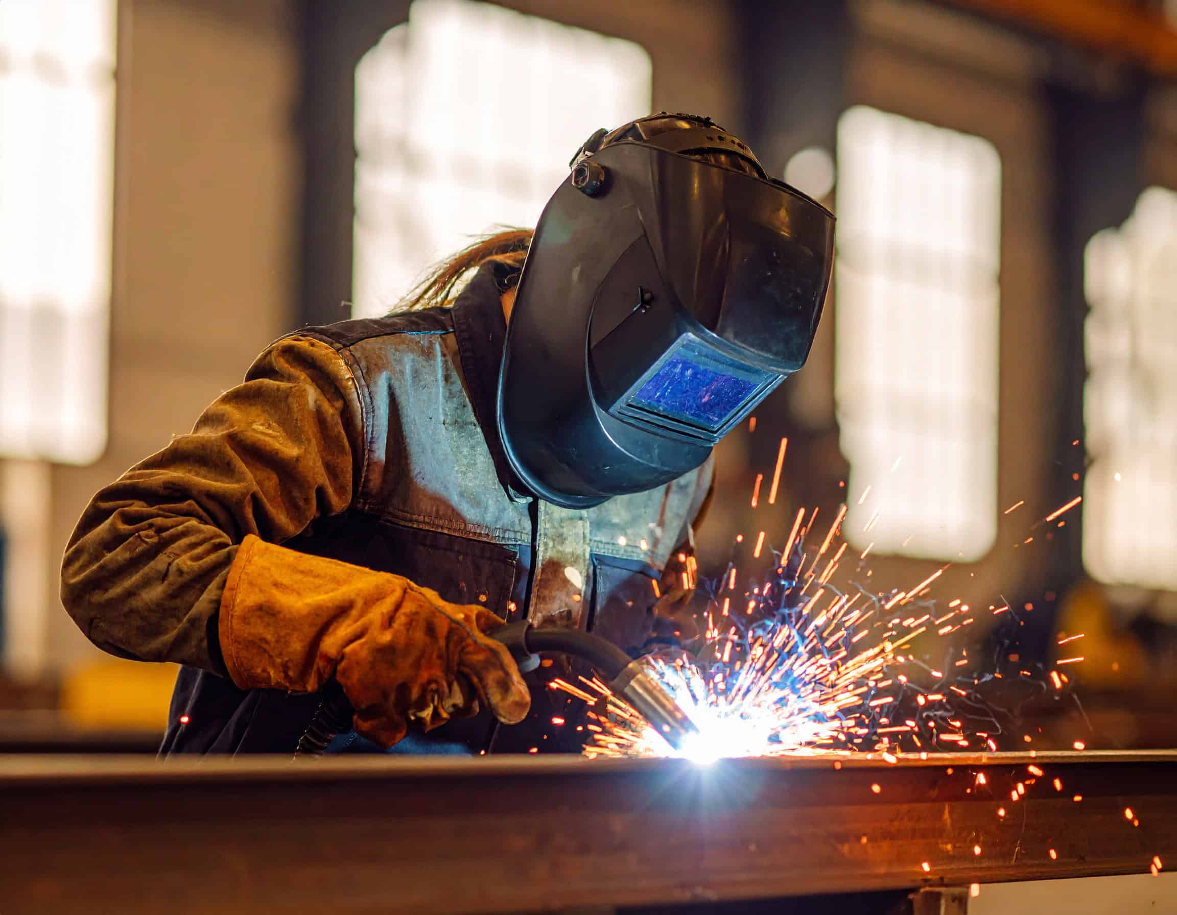
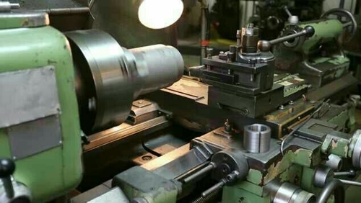
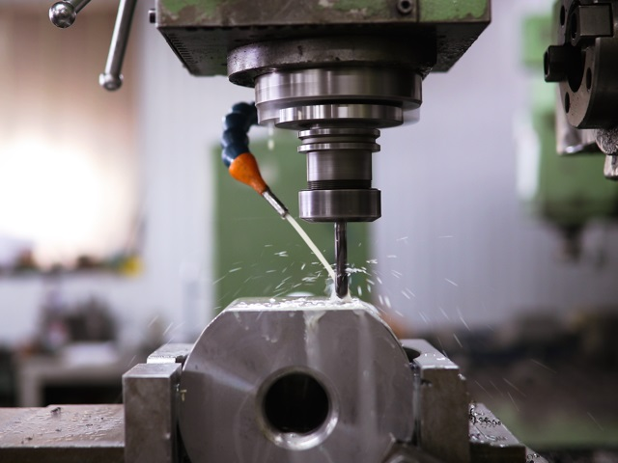

VARDANN TECH and ENGG LLP offers comprehensive precision manufacturing and fabrication services for industrial, engineering, and NDT applications. Our expertise includes precision welding, CNC Turning, CNC Milling, VMC Machining, EDM, Wire Cut EDM, conventional machining, fabrication, and assembly of components.

We manufacture components in Carbon Steel, Stainless Steel, Alloy Steel, Duplex Stainless Steel, Aluminium, Copper Alloys, Titanium, Engineering Plastics, and other materials as per customer requirements.

We undertake prototype development, reverse engineering, job work, and batch production based on customer drawings, samples, and technical specifications. Our commitment to quality, precision, and on-time delivery ensures reliable solutions for diverse industrial applications.

Our Product | 
IN-SITU METALLOGRAPHY KIT
OUR PORTABLE METALLOGRAPHY KITS INCLUDE A HAND-HELD MICROSCOPE (50x–600x) with halogen or LED illumination, filters, and magnetic clamp. A complete manual polishing unit with grinders, mops, lapping tools, and diamond paste ensures field metallography with high precision. Certified as per NPL standards, these tools are ideal for microstructure analysis and ASTM A-262 testing.

UNIVERSAL ELECTROLYTIC POLISHER
A portable, field-ready unit designed for rugged use, it enables polishing and etching in a single operation. The pen-type probe simplifies operation and prevents electrolyte spillage. It is ideal for ASTM A-262 and metallurgical surface preparation on various metals and alloys.

IMAGE ANALYZER & ELECTRONIC EYEPIECE SYSTEM
Our 10 MP electronic eyepiece with advanced software modules enables analysis for grain size (ASTM E112), phase segmentation (ASTM E562), porosity (ASTM 247), graphite flakes (ASTM A247), decarburization (ASTM E1077), coating thickness (ASTM 2639-02), and inclusions (ASTM E45). The system automates measurements for microstructure analysis with precise ASTM-based reporting.

INVERTED TRINOCULAR METALLURGICAL MICROSCOPE
This advanced microscope allows detailed analysis of metallurgical structures after casting, forging, or heat treatment. Equipped with 10x–100x objectives, 6V 30W illumination, and polarizing filters, it’s widely used in foundries, R&D labs, and universities for metallographic research.
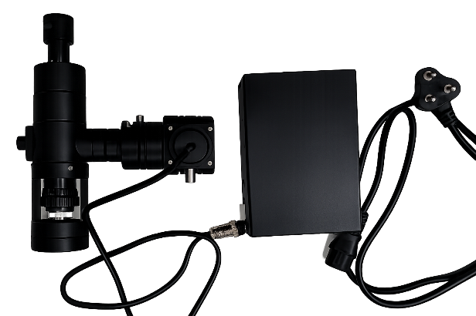 | 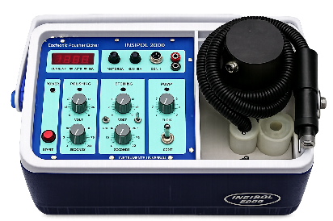 | 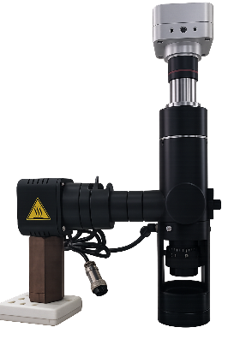
PORTABLE MICROSCOPE | UNIVERSAL ELECTROLYTIC POLISHER | IMAGE ANALYZER & ELECTRONIC EYEPIECE SYSTEM | INVERTED TRINOCULAR METALLURGICAL MICROSCOPE

POST WELD HEAT TREATMENT (PWHT) EQUIPMENT
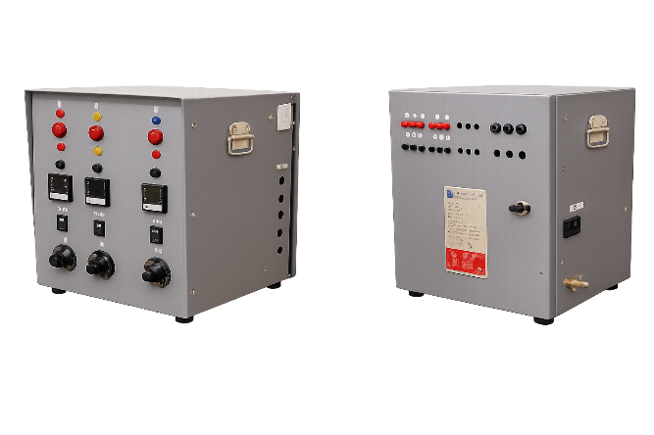
We design durable PWHT control panels available in 3, 6, or 9 channels, each controllable individually or in combination. Units feature PID or manual energy regulation, isolation transformers, RCCB safety, and robust 100A contactors. Compact models like HVP33 provide reliable performance even under rugged conditions.

LOW VOLTAGE HEAT TREATMENT UNIT (75 KVA)
This 75 kVA unit powers up to 24 ceramic heating pads (2.7 kW each), offering precise control for pre- and post-weld heat treatment. Each of the six circuits can operate manually or via PID control. Built with Class H insulation and Albright contactors, it ensures long life, portability, and safety in field and workshop applications.
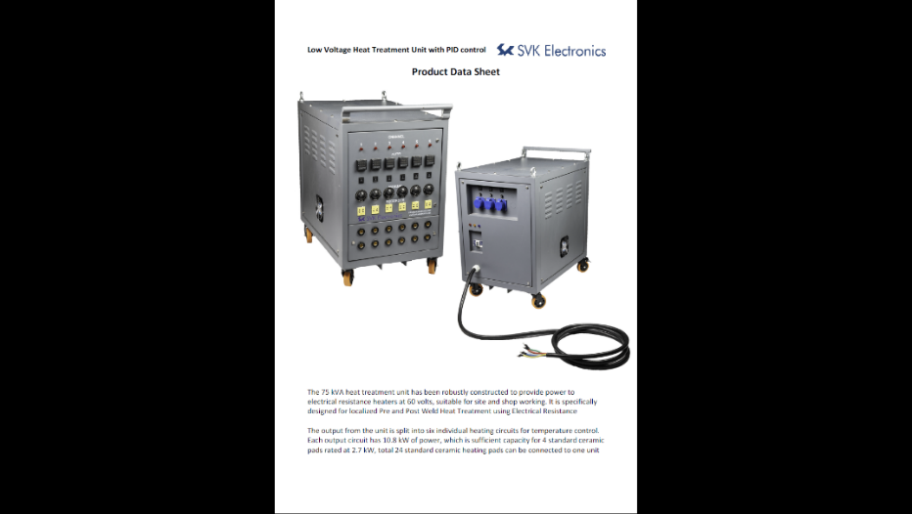
PWHT ACCESSORIES
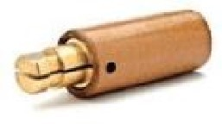  60A male, in-line, Complete, standard sleeve | 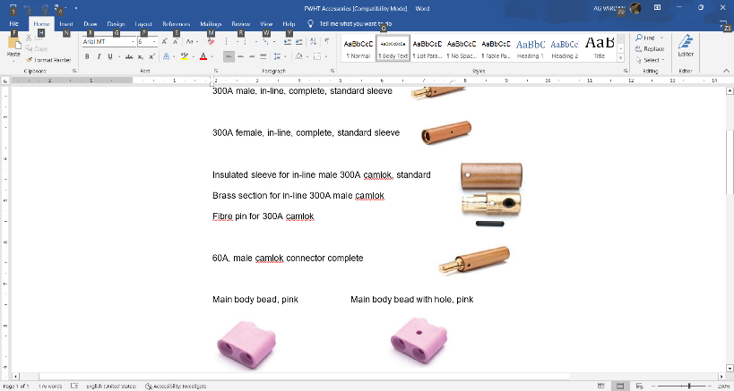  Insulated sleeve for in-line male 300A camlok,  standard Brass section for in-line 300A male camlok  Fibre pin for 300A camlok  60A, male camlok connector complete |  |  |  | 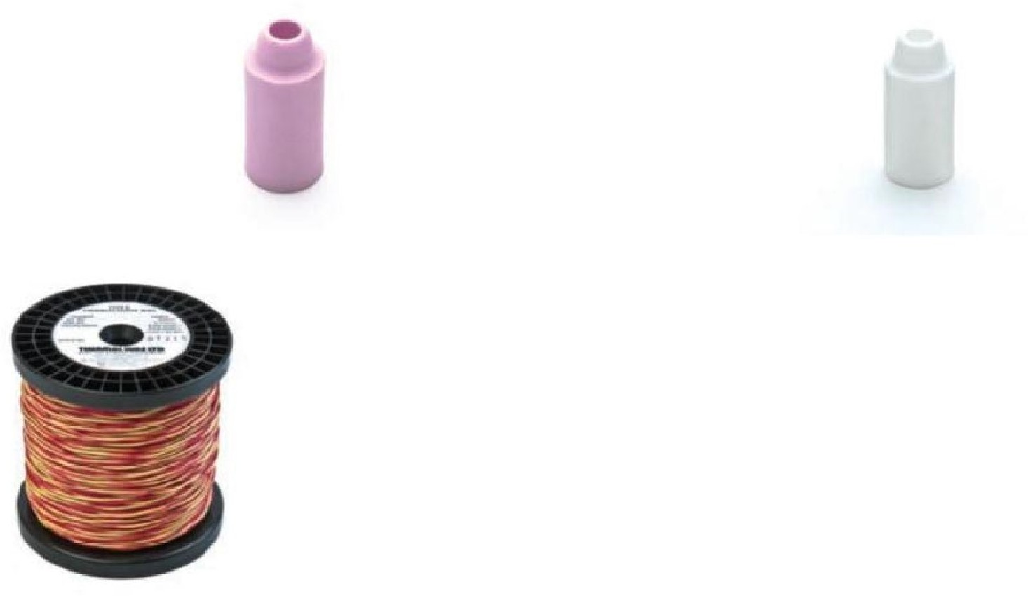 |  | 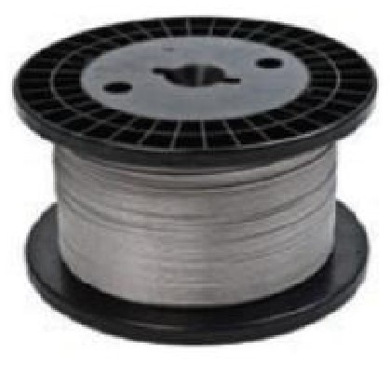 |  | 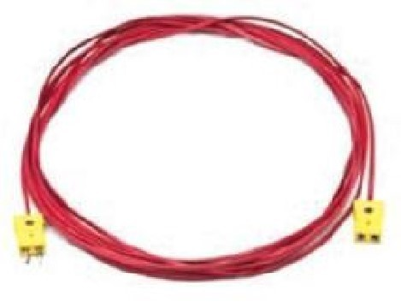  Compensating cable for Type K thermocouple, 30m long |  |  | 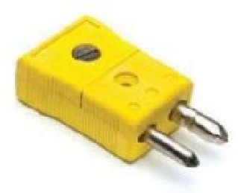  Standard in-line thermocouple plug
 |  |  |  |  | Type K thermocouple conductor wire, twin twisted,0.711mm.- Double Insulated and Single Insulated Heater core wire, 80/20, (19 strand), 0.29 /m / Heater core wire, 60/16, (19 strand), 0.28 /m |  |  |  |  |  |  | 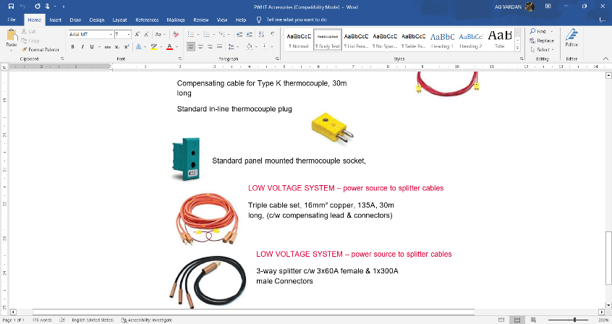  Standard panel mounted thermocouple socket
60A female, in-line, complete, epoxy sleeve  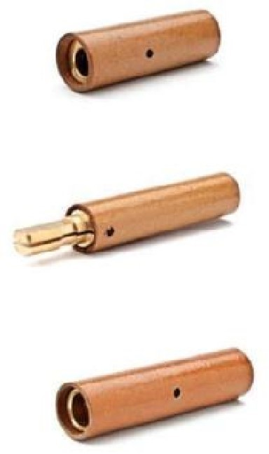  300A male, in-line, complete, standard sleeve  300A female, in-line, complete, standard sleeve | 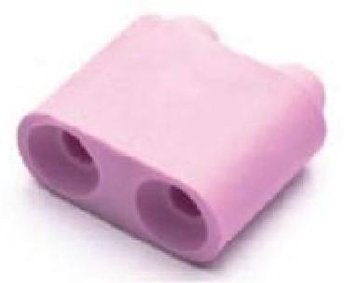  Main body bead, pink | 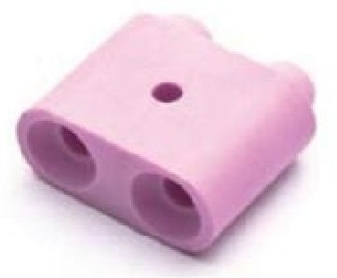  Main body bead with hole, pink | 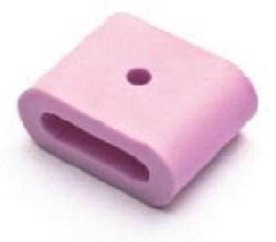  Female end bead with hole, pink | 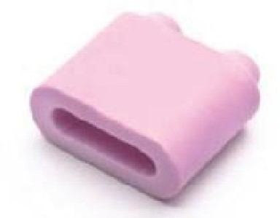  Male end bead, pink |  | 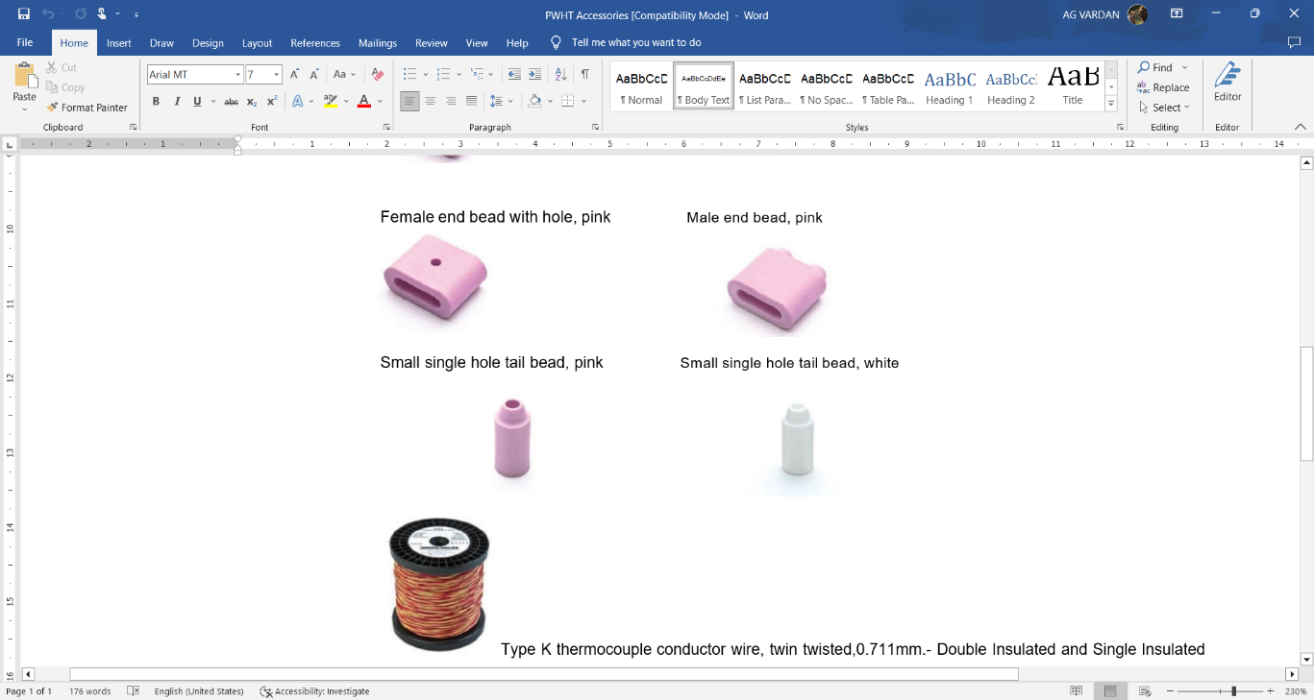  Small single hole tail bead, white |  | 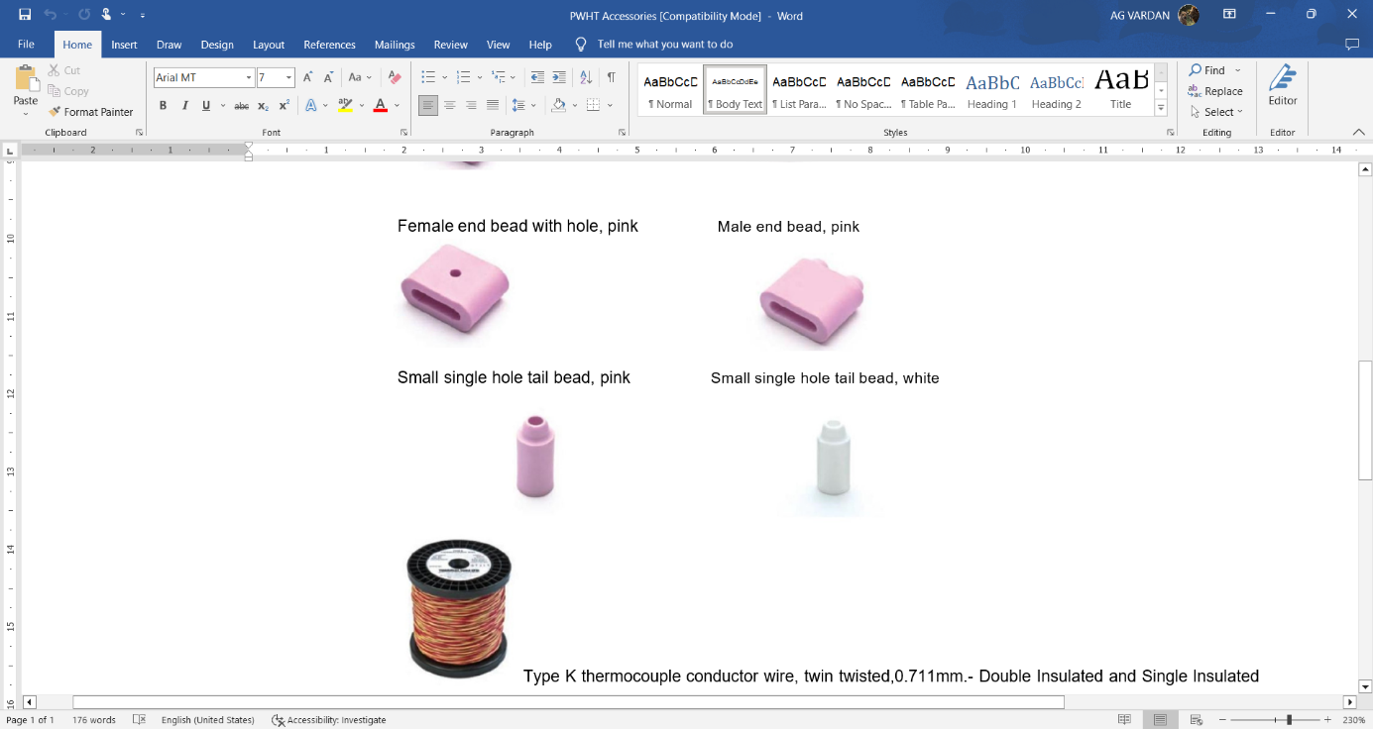  Small single hole tail bead, pink |  | LOW VOLTAGE SYSTEM –  power source to splitter cables |  |  |  | 3-PHASE 380/440V SYSTEM
 |  |  |  |  |  |  |  |  |  | 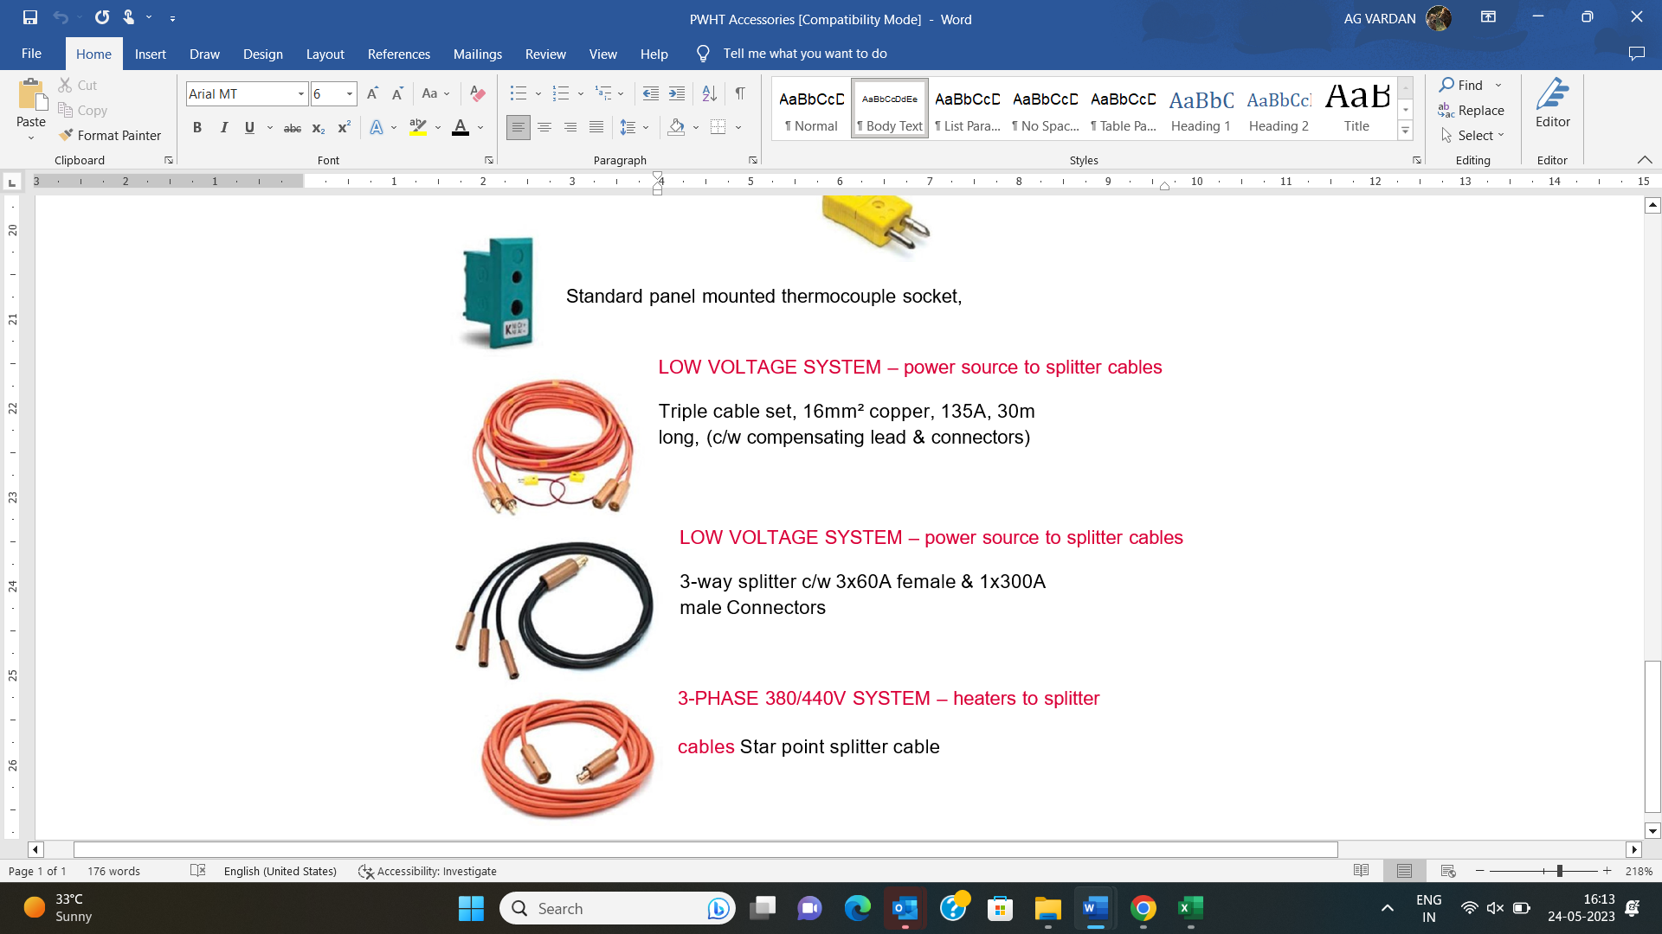 |  |  | 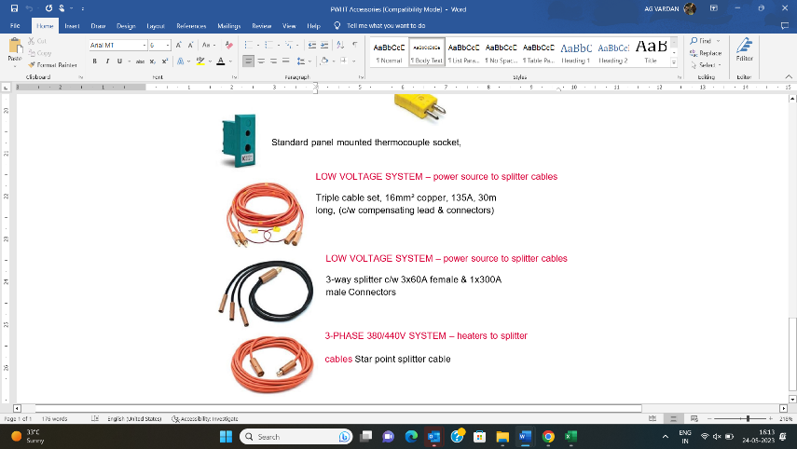
 |  |  |  |  |  |  |  |  |  | Triple cable set, 16mm² copper, 135A, 30m  long, (c/w compensating lead & connectors) | 3-way splitter c/w 3x60A female & 1x300A  male Connectors |  | heaters to splitter cables

ADVANCE NDT  SERVICES | 

TUBE AND TUBULAR INSPECTION SERVICES- (ECT, RFT, IRIS, NFT)

We specialize in Eddy Current (ECT), Remote Field (RFT), Near Field (NFT), and IRIS Ultrasonic Testing for both ferrous and non-ferrous tubes used in heat exchangers, boilers, and condensers.
EDDY CURRENT TESTING (ECT)  Ideal for non-ferrous tubing, ECT detects wall thinning, pitting, and cracking with high accuracy.  It uses absolute and differential channels for wall loss and local defect detection. | 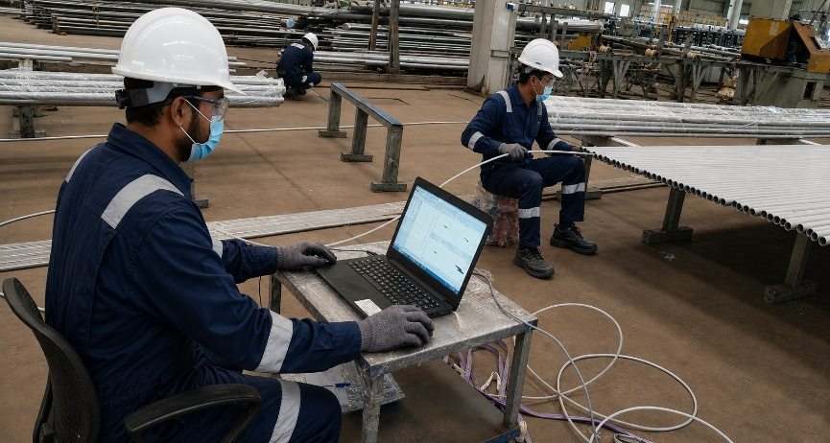
REMOTE FIELD TESTING (RFT)
Designed for ferrous tubing, RFT measures wall thinning and corrosion up to 12 mm.
It provides fast, reliable screening for carbon steel and ferritic alloys.
INTERNAL ROTARY INSPECTION SYSTEM (IRIS)
A precision ultrasonic technique for all materials, IRIS measures remaining wall thickness due to corrosion or erosion.
It provides detailed imaging through B-scan and C-scan views.
NEAR FIELD TESTING (NFT)
Used for fin-fan and air cooler tubes, NFT effectively detects internal corrosion and pitting near the tube inlet.
We perform comprehensive inspection programs during plant shutdowns to ensure reliability and minimize downtime.
Using advanced ECT, RFT, and IRIS systems, our experts provide accurate analysis and defect mapping for continued safe operation.

ADVANCED ULTRASONIC INSPECTION
PHASED ARRAY ULTRASONIC TESTING (PAUT)  PAUT uses multiple ultrasonic beams to detect, size, and image internal flaws.  It delivers superior detection and digital imaging, replacing traditional radiography in many industries.  Advantages: Real-time imaging, data recording, improved accuracy, and no radiation hazard.  TIME-OF-FLIGHT DIFFRACTION (TOFD)  TOFD detects and sizes weld defects using diffracted sound waves.  It’s ideal for new construction and in-service inspections where precision and repeatability are vital.  Advantages: Accurate defect sizing, full weld coverage, digital record, and repeatable results. |  | 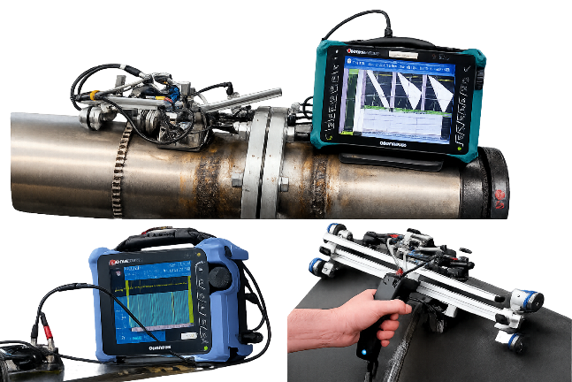

PIPELINE INSPECTION
LONG RANGE ULTRASONIC TESTING (LRUT)  LRUT is used for rapid screening of pipelines above and below ground.  It uses guided waves to inspect long pipe sections without direct access.  Advantages: Fast coverage, minimal excavation, and detection of corrosion or defects over long distances.  PULSED EDDY CURRENT TESTING (PECT)  PECT measures wall thickness through insulation, coatings, or marine growth — ideal for corrosion under insulation (CUI) inspections.  Advantages: No surface preparation, works through non-metallic layers, and detects corrosion in inaccessible areas.  REMOTE VISUAL INSPECTION (BORESCOPE / VIDEOSCOPE)  Borescopes enable visual inspection of inaccessible areas in engines,  heat exchangers, turbines, and welds.  Advantages: Non-destructive, high-resolution imaging, and ideal for internal inspection of complex assemblies. | 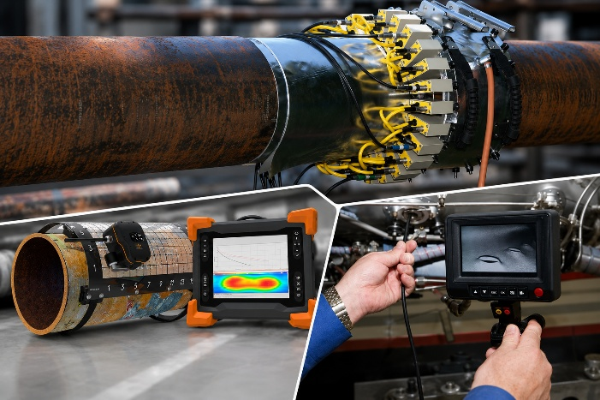

CONVENTIONAL NDT SERVICES | 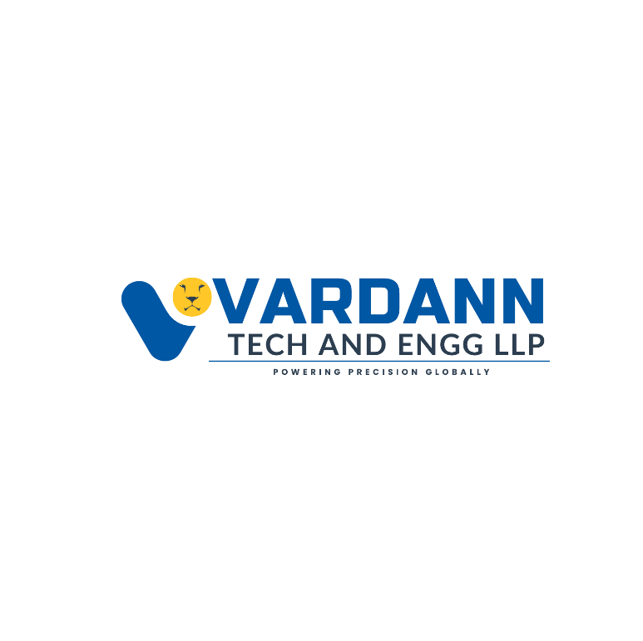

CONVENTIONAL METHODS (UT, UTG, RT, MPT, LPT, CTM, PWHT)

ULTRASONIC THICKNESS GAUGE (UTG)  Ultrasonic Testing uses high-frequency sound waves to determine part thickness and detect internal or surface flaws in base materials and welds. It provides real-time, accurate results, reducing costly downtime.  Advantages: Detects surface and subsurface defects, single-sided access, superior depth penetration, and immediate results.  ULTRASONIC TESTING (UT)  Ultrasonic Testing uses high-frequency sound waves to determine part thickness and detect internal or surface flaws in base materials and welds. It provides real-time, accurate results, reducing costly downtime.  Advantages: Detects surface and subsurface defects, single-sided access, superior depth penetration, and immediate results. | 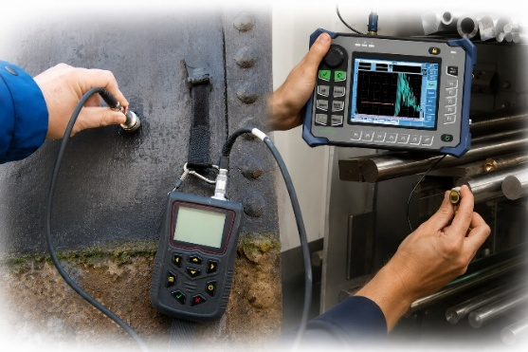

RADIOGRAPHIC TESTING (RT)  Radiographic Testing employs X-rays or gamma rays to detect internal flaws in welds, castings, and pressure components.  It provides volumetric inspection with permanent visual records.  Advantages: Visual record of results, reliable defect characterization, high sensitivity, and proven accuracy across all industries. | 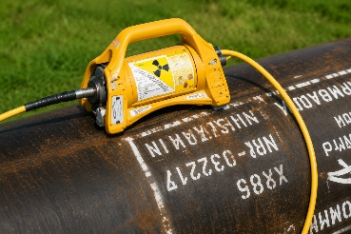

MAGNETIC PARTICLE TESTING (MT)  Magnetic Particle Testing uses magnetic fields and fine iron particles to reveal surface and near-surface discontinuities in ferromagnetic materials.  Advantages: Detects shallow cracks, works on complex geometries, portable, and suitable for quick on-site inspections.  LIQUID PENETRANT TESTING (PT)  Penetrant Testing is ideal for detecting surface discontinuities in non-porous materials.  It offers a quick and cost-effective inspection solution suitable for both production and field use.  Advantages: Detects fine surface flaws, few material limitations, portable, and delivers rapid inspection results. | 

HARDNESS TESTING (HT)  Hardness Testing applies a constant load to a metal surface to measure its resistance to deformation.  It helps verify material strength, quality, and heat treatment effectiveness.  Advantages: Fast, non-destructive, and accurate for quality assurance.  COATING THICKNESS MEASUREMENT  Coating Thickness Gauges are used to measure dry film thickness — a vital factor in ensuring corrosion protection and product durability.  Advantages: Quick, accurate, and essential for quality control in the coating industry. | 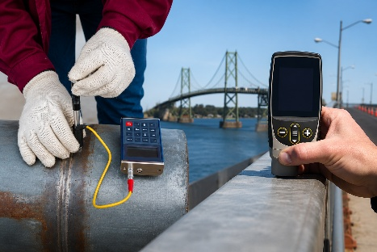

POST WELD HEAT TREATMENT (PWHT)  PWHT relieves residual stresses and restores mechanical properties after welding in critical components such as pressure vessels, piping, and process equipment.  Advantages: Reduces stress, prevents cracking, improves ductility, and enhances material strength. |  | 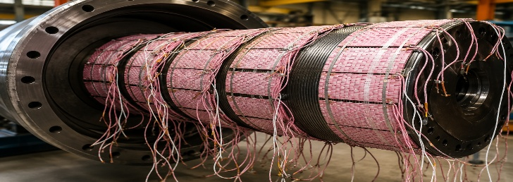
 | DESTRUCTIVE TESTING & TRAINING |  | 
CHEMICAL, METALLURGICAL TESTING
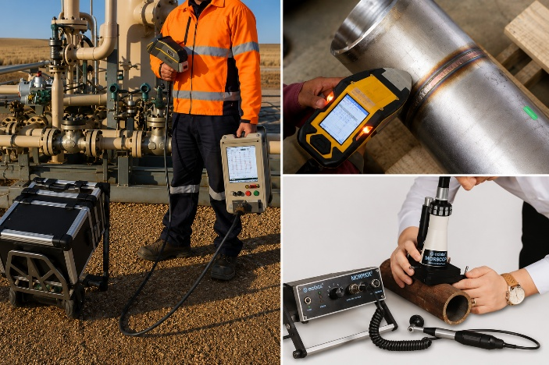
POSITIVE MATERIAL IDENTIFICATION (PMI)
PMI uses portable XRF analysers to identify metal alloy compositions in welds, castings, and components.
Advantages: Rapid alloy verification, accurate element detection, and essential for NACE compliance.

OPTICAL EMISSION SPECTROSCOPY (OES)
OES, also known as Spark Testing, identifies elements by analysing the emitted light spectrum.
It’s vital for confirming material chemistry and preventing material mix-ups.
Advantages: Detects a wide range of elements and ensures material traceability.

IN-SITU METALLOGRAPHY
In-situ metallography examines material microstructures directly at the site without damaging the component.
It’s ideal for weld inspections, power plants, and pipeline systems.
Advantages: On-site microstructure analysis, non-destructive, and suitable for in-service components.

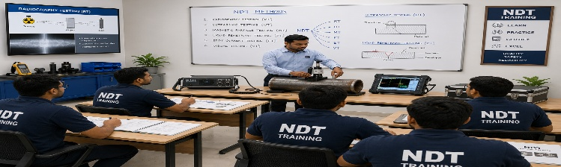
TRAINING & CERTIFICATION
We offer professional training and certification courses in NDT Level I, II, and III as per ASNT standards. Our programs combine theory with hands-on practical sessions for PAUT, TOFD, ECT, RFET, IRIS, UT, MT, and PT methods.
Advantages: Practical learning, certification readiness, flexible schedules, and industry-recognized credential

Why Choose VARDANN TECH AND ENGG LLP?

- Complete NDT Solutions under one roof
- Custom Manufacturing & Engineering Support
- Fast Delivery for Standard Products
- Precision CNC & EDM Manufacturing
- Technical Expertise & Application Support
- Global Supply Capability
- Customer-Focused Engineering Solutions

Our Products and Services Are Supplied To:
🇰🇼 Kuwait | 🇸🇦 Saudi Arabia | 🇶🇦 Qatar | 🇮🇷 Iran | 🇮🇶 Iraq | 🇦🇪 United Arab Emirates | 🇹🇭 Thailand | 🇮🇩 Indonesia | 🇻🇳 Vietnam | 🇦🇺 Australia | 🇳🇿 New Zealand | 🇬🇭 Ghana | 🇺🇬 Uganda | 🇰🇪 Kenya

Your Trusted Partner for NDT Products, Inspection Services & Precision Engineering Solutions.
Delivering Quality. Engineering Confidence. Building Long-Term Partnerships.



Off Add: G-32, Saidham Shopping Plaza, P.K Road, Saidham, Mulund West Mumbai PIN-400080, Maharashtra, India.
E: mail: info@vardanntech.com / admin@vardanntech.com www.vardanntech.com
Mob No: + 91 9664050993 Tel No: + 91 22 3572 4058 Office Mob No.: +91 9619636917

"All information provided in this catalogue is the property of [VARDANN TECH AND ENGG LLP] and is intended for reference purposes only. Any misuse, reproduction, or distribution without prior written consent is strictly prohibited."

